Practical 10 Develop an android application to store data locally using SharedPreferences and access-modify in different activities.

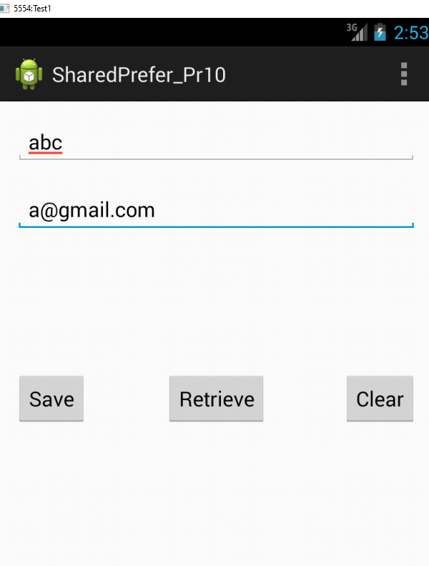

**activity_main.xml**

<RelativeLayout xmlns:android=*"http://schemas.android.com/apk/res/android"*

xmlns:tools=*"http://schemas.android.com/tools"*

android:layout_width=*"match_parent"*

android:layout_height=*"match_parent"*

android:paddingBottom=*"@dimen/activity_vertical_margin"*

android:paddingLeft=*"@dimen/activity_horizontal_margin"*

android:paddingRight=*"@dimen/activity_horizontal_margin"*

android:paddingTop=*"@dimen/activity_vertical_margin"*

tools:context=*".MainActivity"* >

<Button

android:id=*"@+id/btnSave"*

android:layout_width=*"wrap_content"*

android:layout_height=*"wrap_content"*

android:layout_centerVertical=*"true"*

android:layout_alignParentLeft=*"true"*

android:layout_alignParentStart=*"true"*

android:onClick=*"Save"*

android:text=*"Save"* />

<Button

android:id=*"@+id/btnRetr"*

android:layout_width=*"wrap_content"*

android:layout_height=*"wrap_content"*

android:layout_centerHorizontal=*"true"*

android:layout_centerVertical=*"true"*

android:onClick=*"Get"*

android:text=*"Retrieve"* />

<Button

android:id=*"@+id/btnClear"*

android:layout_width=*"wrap_content"*

android:layout_height=*"wrap_content"*

android:layout_alignRight=*"@+id/etEmail"*

android:layout_centerVertical=*"true"*

android:layout_alignParentRight=*"true"*

android:layout_alignParentEnd=*"true"*

android:onClick=*"clear"*

android:text=*"Clear"* />

<EditText

android:id=*"@+id/etEmail"*

android:layout_width=*"match_parent"*

android:layout_height=*"wrap_content"*

android:ems=*"10"*

android:hint=*"Email"*

android:inputType=*"textEmailAddress"*

android:layout_below=*"@+id/etName"*

android:layout_marginTop=*"20dp"*

android:layout_alignParentRight=*"true"*

android:layout_alignParentEnd=*"true"* />

<EditText

android:id=*"@+id/etName"*

android:layout_width=*"match_parent"*

android:layout_height=*"wrap_content"*

android:ems=*"10"*

android:hint=*"Name"*

android:inputType=*"text"*

android:layout_alignParentTop=*"true"*

android:layout_alignLeft=*"@+id/etEmail"*

android:layout_alignStart=*"@+id/etEmail"* />

</RelativeLayout>

MainActivity.java

**package** com.example.sharedprefer_pr10;

**import** android.os.Bundle;

**import** android.app.Activity;

**import** android.content.Context;

**import** android.content.SharedPreferences;

**import** android.view.Menu;

**import** android.view.View;

**import** android.widget.TextView;

**public** **class** MainActivity **extends** Activity {

SharedPreferences sharedpreferences;

TextView name;

TextView email;

**public** **static** **final** String *mypreference* = "mypref";

**public** **static** **final** String *Name* = "nameKey";

**public** **static** **final** String *Email* = "emailKey";

@Override

**protected** **void** onCreate(Bundle savedInstanceState) {

**super**.onCreate(savedInstanceState);

setContentView(R.layout.*activity_main*);

name = (TextView) findViewById(R.id.*etName*);

email = (TextView) findViewById(R.id.*etEmail*);

sharedpreferences = getSharedPreferences(*mypreference*,

Context.*MODE_PRIVATE*);

**if** (sharedpreferences.contains(*Name*)) {

name.setText(sharedpreferences.getString(*Name*, ""));

}

**if** (sharedpreferences.contains(*Email*)) {

email.setText(sharedpreferences.getString(*Email*, ""));

}

}

**public** **void** Save(View view) {

String n = name.getText().toString();

String e = email.getText().toString();

SharedPreferences.Editor editor = sharedpreferences.edit();

editor.putString(*Name*, n);

editor.putString(*Email*, e);

editor.commit();

}

**public** **void** clear(View view) {

name = (TextView) findViewById(R.id.*etName*);

email = (TextView) findViewById(R.id.*etEmail*);

name.setText("");

email.setText("");

}

**public** **void** Get(View view) {

name = (TextView) findViewById(R.id.*etName*);

email = (TextView) findViewById(R.id.*etEmail*);

sharedpreferences = getSharedPreferences(*mypreference*,

Context.*MODE_PRIVATE*);

**if** (sharedpreferences.contains(*Name*)) {

name.setText(sharedpreferences.getString(*Name*, ""));

}

**if** (sharedpreferences.contains(*Email*)) {

email.setText(sharedpreferences.getString(*Email*, ""));

}

}

@Override

**public** **boolean** onCreateOptionsMenu(Menu menu) {

// Inflate the menu; this adds items to the action bar if it is present.

getMenuInflater().inflate(R.menu.*main*, menu);

**return** **true**;

}

}